DSC 450: Database Processing for Large-Scale Analytics

Assignment Module 4

Nick Jones

Part 1

- Using the extended Zoo database (ZooDatabase_extended.sql), write the following queries in SQL:

- Find all the rare animals and sort the query output by feeding time (from small to large)
SELECT Aname, Acategory, Timetofeed
From Animal
WHERE Acategory = 'rare'
ORDER BY Timetofeed ASC;
- Find the animal names and categories for animals related to a bear (hint: use the LIKE operator)
SELECT Aname, Acategory From Animal
WHERE Aname LIKE '%bear';
- Find the names of the animals that are related to the tiger and are not common
SELECT Aname FROM Animal
WHERE Aname LIKE '%tiger' AND NOT Acategory = 'common';
- Find the names of the animals that are not related to the tiger
SELECT Aname FROM Animal
WHERE Aname NOT LIKE '%tiger';
- List the animals (animal names) and the ID of the zoo keeper assigned to them.
SELECT Animal.Aname,Handles.ZooKeepID FROM Animal, Handles
WHERE Animal.AID = Handles.AnimalID;
- Now repeat the previous query and make sure that the animals without an assigned handler also appear in the answer.
SELECT Animal.Aname,Handles.ZooKeepID
FROM Animal LEFT OUTER JOIN Handles
ON Animal.AID = Handles.AnimalID;
- Report, for every zoo keeper name, the average number of hours they spend feeding all animals in their care.
SELECT Zookeeper.zname, ROUND(AVG(Animal.Timetofeed) ,2) as AvgHour
FROM Zookeeper JOIN HANDLES
ON Zookeeper.ZID = Handles. zookeepID
JOIN Animal
ON Handles.animalID = Animal.AID
GROUP BY Zookeeper.zname;
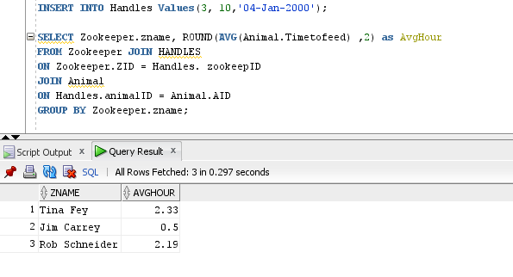
- Report every handling assignment (as a list of assignment date, zoo keeper name and animal name). Sort the result of the query by the assignment date in an ascending order.
SELECT h.Assigned,z.ZName,a.AName
FROM Zookeeper z JOIN HANDLES h
ON z.ZID = h. zookeepID
JOIN Animal a
ON h.animalID = a.AID
ORDER BY h.assigned ASC;
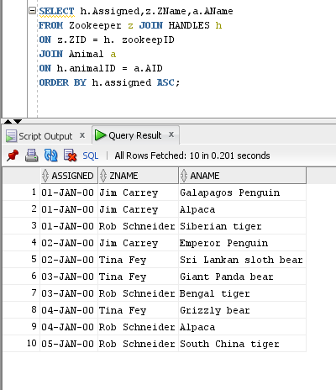

- Repeat the following queries using python (i.e., by reading data from animal.txt, without using a database)

- Find the names of the animals that are related to the tiger and are not common
- Find the names of the animals that are not related to the tiger

def tigerNotcommon():
with open("C:/Users/Owner/Documents/DSC 450/animal.txt",'r') as inFile:
data = inFile.readlines()
for i in data:
i = i.strip()
lst = i.split(',')
if('tiger' in lst[1] and 'common' not in lst[2]):
print(lst[1])

def notTiger():
with open("C:/Users/Owner/Documents/DSC 450/animal.txt",'r') as inFile:
data = inFile.readlines()
for i in data:
i = i.strip()
lst = i.split(',')
if('tiger' not in lst[1]):
print(lst[1])

print('Here are the animals that are related to the tiger and are not common: ')
tigerNotcommon()

print('Here are the animals that are not related to the tiger:')
notTiger()

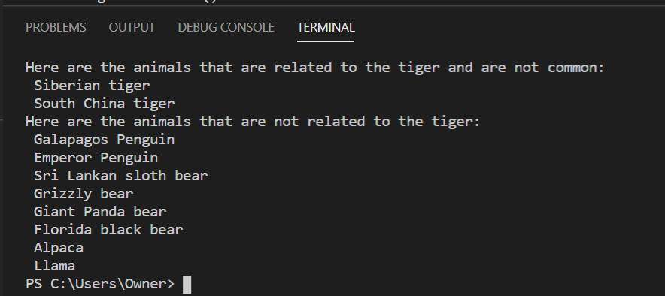

Part 2

- You are given a following schema in 1NF:
(First, Last, Address, Job, Salary, Assistant) and the following set of functional dependencies:

First, Last → Address
Job → Salary, Assistant

Decompose the schema to make sure it is in Third Normal Form (3NF).

Worker(W_First, W_ Last, Address)

Jobs(J_Job, Salary, Assistant)

Info(I_First, I_Last, I_Job)

- Write the necessary SQL DDL statements (CREATE TABLE) to define these the tables you created
CREATE TABLE Worker
(
W_First VARCHAR2(25) NOT NULL,
W_Last VARCHAR2(25) NOT NULL,
Address VARCHAR2(40),

PRIMARY KEY(W_First, W_Last)
);

CREATE TABLE Jobs
(
J_Job VARCHAR2(25) NOT NULL,
Salary NUMBER(25),
Assistant VARCHAR2(40),

PRIMARY KEY(J_Job)

);

CREATE TABLE Info
(
I_First VARCHAR2(25) NOT NULL,
I_Last VARCHAR2(25) NOT NULL,
I_Job VARCHAR2(40) NOT NULL,

PRIMARY KEY(I_First,I_Last,I_Job),

FOREIGN KEY(I_First,I_Last)
REFERENCES Worker(W_First, W_Last),

FOREIGN KEY(I_Job)
REFERENCES Jobs(J_Job)
);
- Write a python script that is going to create your tables and populate them with data automatically from data_module4_part2.txt (file attached). You do not have to use executemany, your python code can load data row-by-row. Make sure that you are inserting a proper NULL into the database. HINT: You can use INSERT OR IGNORE statement (instead of a regular INSERT statement) in SQLite to skip over duplicate primary key inserts without throwing an error.

For example:
cursor.execute("INSERT OR IGNORE INTO Animal VALUES(?,?,?,?)", [11, 'Llama', None, 3.5]);
would automatically ignore the insert if animal with ID 11 already exists in the database and insert a NULL into the third column. If you use ‘NULL’ value instead, animal category would be set to the 4-character string ‘NULL’
import sqlite3
createtbl1 = '''''
CREATE TABLE Worker
(
W_First VARCHAR2(25) NOT NULL,
W_Last VARCHAR2(25) NOT NULL,
Address VARCHAR2(40),

PRIMARY KEY(W_First, W_Last)
);
'''
createtbl2 = '''''
CREATE TABLE Jobs
(
J_Job VARCHAR2(25) NOT NULL,
Salary NUMBER(25),
Assistant VARCHAR2(40),
PRIMARY KEY(J_Job)
);
'''
createtbl3 = '''''
CREATE TABLE Info
(
I_First VARCHAR2(25) NOT NULL,
I_Last VARCHAR2(25) NOT NULL,
I_Job VARCHAR2(40) NOT NULL,
PRIMARY KEY(I_First,I_Last,I_Job),
FOREIGN KEY(I_First,I_Last)
REFERENCES Worker(W_First, W_Last),
FOREIGN KEY(I_Job)
REFERENCES Jobs(J_Job)
);
'''
conn = sqlite3.connect('dsc450.db') # open the connection
cursor1 = conn.cursor()#create 3 different cursor connection for 3 tables
cursor2 = conn.cursor()
cursor3 = conn.cursor()
cursor1.execute('DROP TABLE Worker')
cursor2.execute('DROP TABLE Jobs')
cursor3.execute('DROP TABLE Info')
#create 3 tables by 3 different cursors
cursor1.execute(createtbl1)
cursor2.execute(createtbl2)
cursor3.execute(createtbl3)
insert1 = "INSERT OR IGNORE INTO Worker VALUES('%s', '%s','%s');"
insert2 = "INSERT OR IGNORE INTO Jobs VALUES(?, ?, ?);"
insert3 = "INSERT OR IGNORE INTO Info VALUES(?,?,?);"
with open('C:/Users/Owner/Documents/DSC450/Module4/data_module4_part2.txt', 'r') as inFile:
allData = inFile.readlines()
for row in allData:
value = row.strip().split(', ')
#insert value for 3 table by each cursor
cursor1.execute(insert1 % (value[0], value[1], value[2]))
cursor2.execute(insert2 , (value[3], value[4], value[5]))

cursor3.execute(insert3 ,(value[0], value[1], value[3]))
#execute the select all data from each table by each cursor
result1 = cursor1.execute('SELECT * FROM Worker')
result2 = cursor2.execute('SELECT * FROM Jobs')
result3 = cursor3.execute('SELECT * FROM Info')

inFile.close()
conn.commit()
#fetch all the result
r1 = result1.fetchall()
r2 = result2.fetchall()
r3 = result3.fetchall()
print('SELECT * FROM Worker; \n' + str(r1))
print('\nSELECT * FROM Jobs; \n' + str(r2))
print('\nSELECT * FROM Info; \n' + str(r3))
conn.close()

